**Development Director**

**We are on a mission to champion change and celebrate diversity in classical music– do you have the fundraising skills to help us?**

After nine successful years of growth, underpinned by a strong mission, clear artistic vision and successful fundraising, the Chineke! Foundation is looking for a Development Director to lead fundraising and stakeholder management. The Development Director will play a vital role in helping the Chineke! Foundation fulfil its potential.

The Development Director will be responsible for fundraising from all sources, including trusts and foundations, public funders, corporate sponsors and individuals. Reporting to the Managing  
Director and working as a part of our small, dynamic team of management staff, Chineke!’s Development Director will play a vital role in securing funding for projects including concerts and tours by the Chineke! Orchestra and Chineke! Junior Orchestra, and our Learning & Participation programme. You will work closely with colleagues to gain an in-depth understanding of all projects, including budgets, which will enable you to make applications to carefully targeted potential sources.

**Person specification**

Essential:

* Extensive fundraising experience and proven track record of delivery of securing multiple 5 and 6-figure grants from a range of sources
* Experience of researching and writing successful trust and foundation applications
* Experience with managing a fundraising database
* Experience working with colleagues to establish project budgets and plans
* Experience of managing and reporting on major multi-year grants
* Understanding of current fundraising issues – including the motivation behind organisations’ inclination to give, whether corporate, trusts, individuals or public bodies
* Ability to identify and follow up in a timely manner on all potential sources of funding
* A high standard of communication in written and spoken English
* Ability to talk confidently to potential and existing supporters about Chineke! and its work
* Outstanding networking skills in a range of settings
* Ability to work from home and Chineke! office at Woolwich Works in Greenwich
* Commitment to advancing the cause of diversity in the arts
* A strong work ethic, ability to work autonomously, and a willingness to work occasional irregular hours including weekends and/or whenever projects take place
* Strong general IT skills

Desirable:

* A strong understanding of classical music and the industry around it
* Experience of fundraising in classical music or the arts sector more generally
* Experience in reporting for a Arts Council National Portfolio Organisation
* Background pattern

  Description automatically generatedExperience reporting directly to a Board of trustees

**Job description**

Reporting to the Managing Director and in coordination with the MD, Artistic Director and Learning & Participation Manager, you will work to identify and understand all future Chineke! projects and their funding needs.

* Research appropriate Trusts, Foundations, Individuals and Corporate sponsors to whom you will make written applications
* Meet with potential supporters to understand their giving criteria
* Write applications which meet our funding needs and the giving criteria of potential donors, and submit applications either by post or on-line
* Attend Chineke! projects as necessary to gain an in-sight into their success
* Write post-project reports to major funders, as required
* Attend Chineke! board meetings to report to the trustees on fundraising progress including applications made and their outcome, and applications planned
* Ensure that donors’ funding requirements are met, for example inclusion of name and log in concert programmes, mention in Chineke! audited accounts
* Work in co-ordination with the Managing Director on applications to Arts Council England
* Maintain a data-base of all applications made and their outcome
* Organise fundraising events to attract support particularly from individual donors
* Contribute to the Development Plan by writing a Fundraising Strategy which will inform and guide Chineke!’s fundraising activities over the coming five years
* Contributing to a supportive and collegiate culture within the Chineke! Orchestra

**Terms of Employment:**

* Salary: £45,000 - £49,000 depending on experience
* Working hours: this is a full-time position, working an average of 40 hours per week including some work outside of regular office hours and at weekends.
* The work will involve a balance of working from Chineke! Foundation’s offices at Woolwich Works in the Royal Borough of Greenwich, working at rehearsal and concert venues and working from home
* 20 days’ holiday per annum plus statutory holidays in the first year of employment rising by 1 day’s holiday per annum for each year of service up to a maximum of 25 days’ holiday, plus statutory holidays.
* Probationary period of six months during which one month’s notice on both sides. After the probationary period, there will be two months’ notice on both sides.
* There will be a number of professional development opportunities connected to this role and these will be developed in collaboration with the successful candidate

**How to apply**

If you have any queries, or wish to apply for the post, please send your CV and covering letter to Ellie Argente, Concert and Tour Manager: ellie@chineke.org

**Application Deadline**: Monday 29th April 6pm **Interviews**: May 2024

**More about Chineke!**

Established in 2015, Chineke! aims to transform public perceptions of who classical music is by and for. We are doing this by developing the Chineke! Orchestra, Europe’s first majority-Black and ethnically diverse professional orchestra. Our founding was described as a “blaze of excitement and hope” (Daily Telegraph) and “the beginning of something culturally inspiring” (The Guardian). Since then we’ve staged 145 concerts and released three full-length commercial recordings, benefitting 350 musicians and reaching a live audience of 90,000 across the UK and internationally. Most recently we delivered our first-ever North American tour, spanning 6 cities and a landmark sold-out performance at New York’s Lincoln Center.

Under the visionary leadership of Chi-chi Nwanoku CBE, our Founder & Artistic Director, Chineke! has become a beacon of innovation and diversity globally in the classical music landscape. Chi-chi Nwanoku’s commitment to excellence and inclusivity is the driving force behind Chineke!'s success and expansion.

Our activities are organised into three primary strands. First, concerts by the Chineke! Orchestra, Chamber Ensemble, and Chineke! Voices, and the new works we regularly commission for the orchestra. Second, the Chineke! Junior Orchestra, which provides development opportunities for ethnically diverse musicians aged 11-22 and comprises courses, rehearsal weekends and concerts. And finally, our Learning & Participation programme in schools and other community settings, also including our new Beginners’ Orchestra.

Chineke! stands as a pioneering force in classical music, dedicated to showcasing the talent of Black and ethnically diverse musicians in the realm of symphonic orchestral performances. Alongside our core focus, we also embrace innovative collaborations that extend our impact and resonate with a wide audience. We've had the privilege of working with notable artists across different genres, such as Stormzy and Max Richter, and partnered directly with the estate of Bob Marley to reimagine Marley’s work in a project released by Island Records. This year, we marked another milestone by becoming the first European orchestra to perform the Black Panther soundtrack live alongside the film, in a special engagement at the Royal Albert Hall. Our current major partnerships include iconic classical music label Decca Recordings, leading cultural centre the Southbank Centre, and emerging arts hub Woolwich Works. In April 2023, Chineke! became an Arts Council England 'National Portfolio Organisation,' further enabling an ambitious expansion of our work across England and beyond.

For further information on the Chineke! Foundation, visit our website at: [www.chineke.org](http://www.chineke.org)

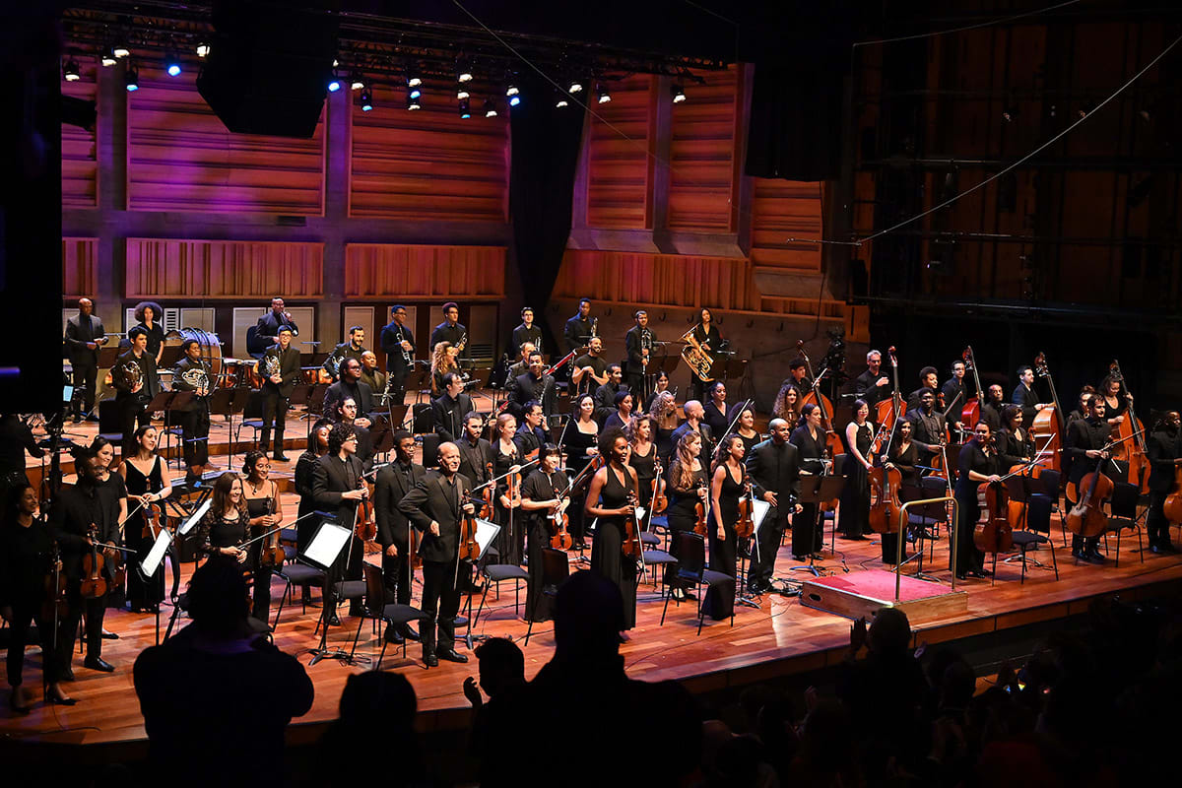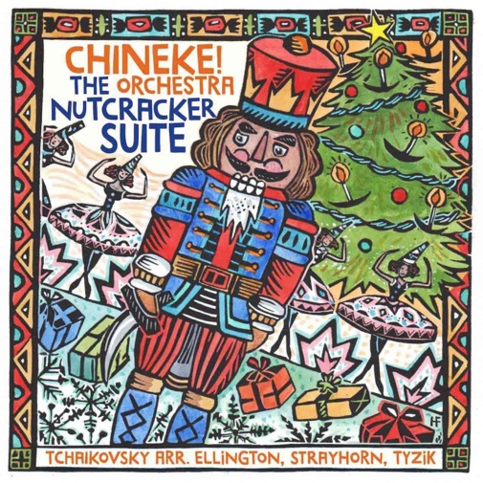*The Chineke! Foundation is a Registered Charity in England and Wales, Charity Number 1165933*